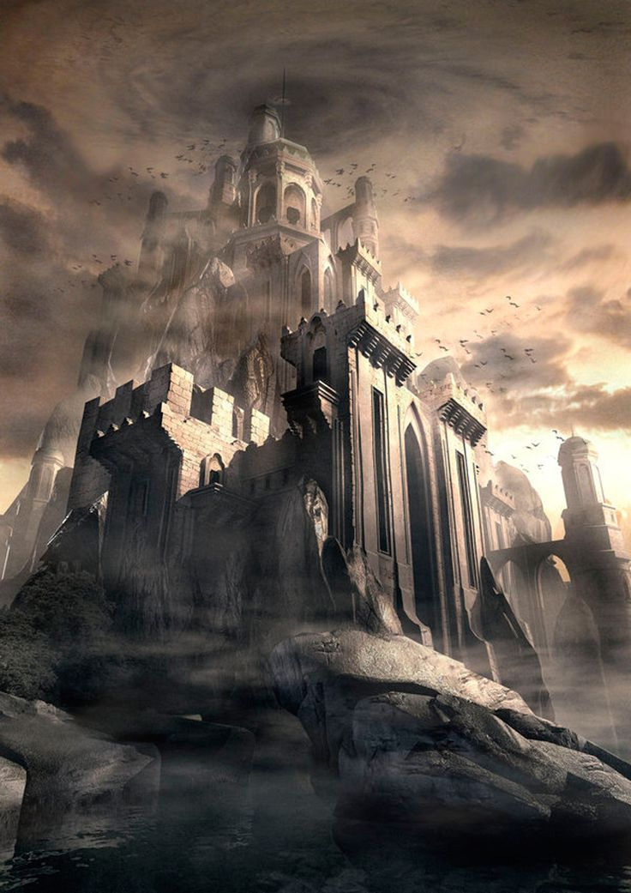

[1]

**Level Design Document – Multiplayer UT4 Level**

|  |  |
| --- | --- |
| Designer | Theodore McCormick |
| Level Name | BridgeFort |
| Due Date | 11/20/17 |

|  |  |  |
| --- | --- | --- |
| Document Revisions | | |
| Date | **Description** | **Initials** |
| 11/20/17 | Initial Document Creation | TRM |

Contents

1. Overview 4

Map 4

Summary 4

Hook(s) 4

Development Schedule 6

2. Gameplay 7

Flag Room 7

Detailed Area Map 7

Area Description 7

Requirements 7

Spawn Room 8

Detailed Area Map 8

Area Description 8

Requirements 8

Tower-Bridge 9

Detailed Area Map 9

Area Description 9

Requirements 9

3. Aesthetics 10

General Thematic Elements 10

Flag Room 10

Special Thematic Elements 10

Lighting 10

Visual References 10

Spawn Room 12

Special Thematic Elements 12

Lighting 12

Visual References 12

Tower-Bridge 14

Special Thematic Elements 14

Lighting 14

Visual References 14

4. References 16

# Overview

## Map

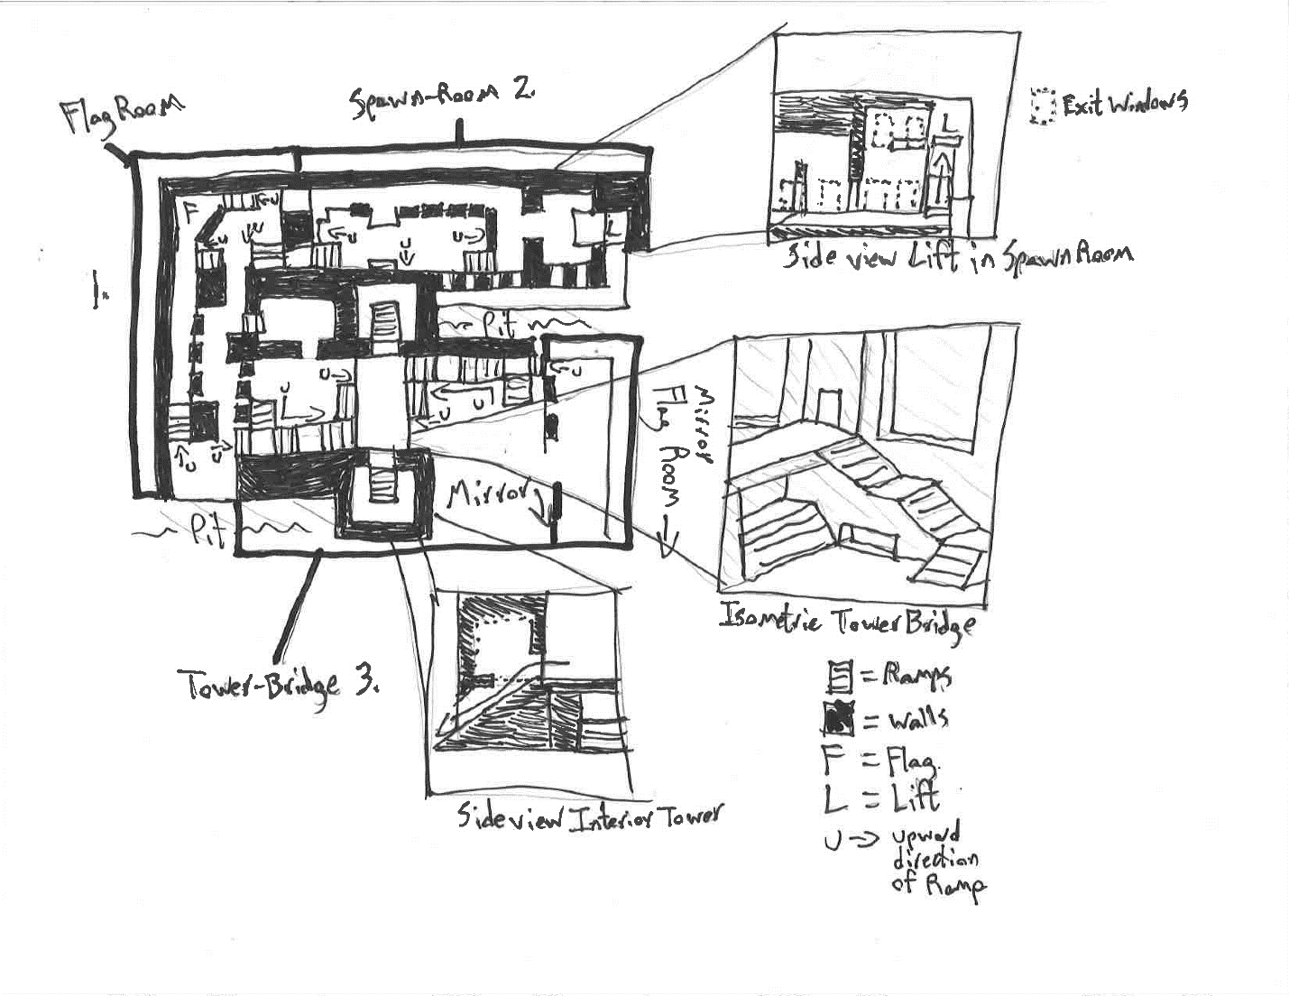

## Summary

BridgeFort is a multiplayer capture-the-flag map designed to work with Unreal Tournament 4, with an emphasis on short and mid-range combat through weapon choices and level layout. Bridgefort’s flag room is based on a hard in, easy out design where players must fight their way into the flag room from two defensive positions, and once in, can escape with the flag aided by those same defenses. The outer lane, or “Spawn Room”, encourages player movement towards the mid area, called the “Tower-Bridge”, or towards the flag room via narrow directive corridors.

BridgeFort takes place in a cliffside mountain setting, with two large castle-like forts as the flag bases, and two main paths between them: a long S shaped valley, and a straight, short, two-towered bridge as the mid.

## Hook(s)

* A central bridge in the “Tower-Bridge” area with competitive control of a rocket launcher on top, and a U-Damage down below.
* A bottomless pit between the “Spawn-Room” and the “Tower-Bridge” with a balcony that players can jump across as a one way exit to the Tower-Bridge. This same balcony has an entrance to an elevator where players can access hidden Jump-Boots, allowing a savvy player to jump back and forth across the pit.

## Development Schedule

|  |  |  |
| --- | --- | --- |
| Date | Milestone | Requirement |
| **11/20/2017** | Level Design Document | * Detailed maps of all areas and gameplay. * Document includes all spawns, weapons, health, armor and Flag locations. * Visual References and Contact sheet compiled. |
| **11/27/2017** | Lighting Complete | * Lighting is representative of final lighting. * Weapon choices are finalized. * Gameplay spaces are finalized in general, with room for refinement. * Meshes by texture are represented at least minimally in all spaces. |
| **12/1/2017** | Mesh Complete | * All BSP is replaced with static meshes. * Gameplay refinement continues with new assets in place. * Lighting is iterated with new assets in place based on player feedback. |
| **12/7/2017** | Final Map | * All gameplay assets, meshes, and lighting elements are finalized. * Gameplay is complete. |

# Gameplay

## Flag Room

### Detailed Area Map

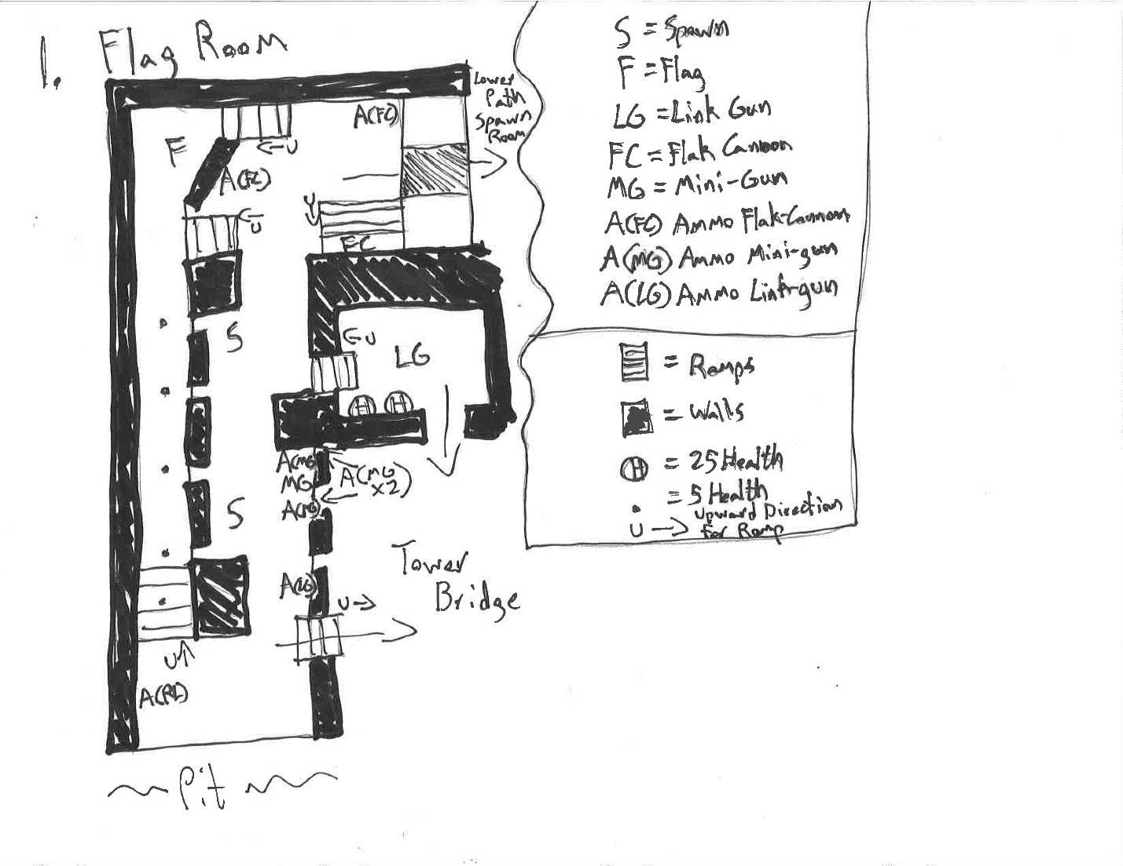

### Area Description

The flag room is based on a hard in, easy out design where players must fight their way into the flag room from two defensive positions, a Mini-Gun position behind cover, and a narrow entrance near the Spawn Room. Once in, players can escape with the flag aided by similar defenses. Players can either escape towards the Tower-Bridge through an elevated ramp protected by pillars, or towards the Spawn Room through a lower, partially covered, exit. For the defending team, there is a Flak Cannon and two ammo canisters located near the flag, though placed outside of cover so that the defending player must expose themselves to restock. There are two spawn points located near the Mini-Gun position, and near a shortcut to the Tower-Bridge area.

### Requirements

No special assets or scripts are required for this area.

## Spawn Room

### Detailed Area Map

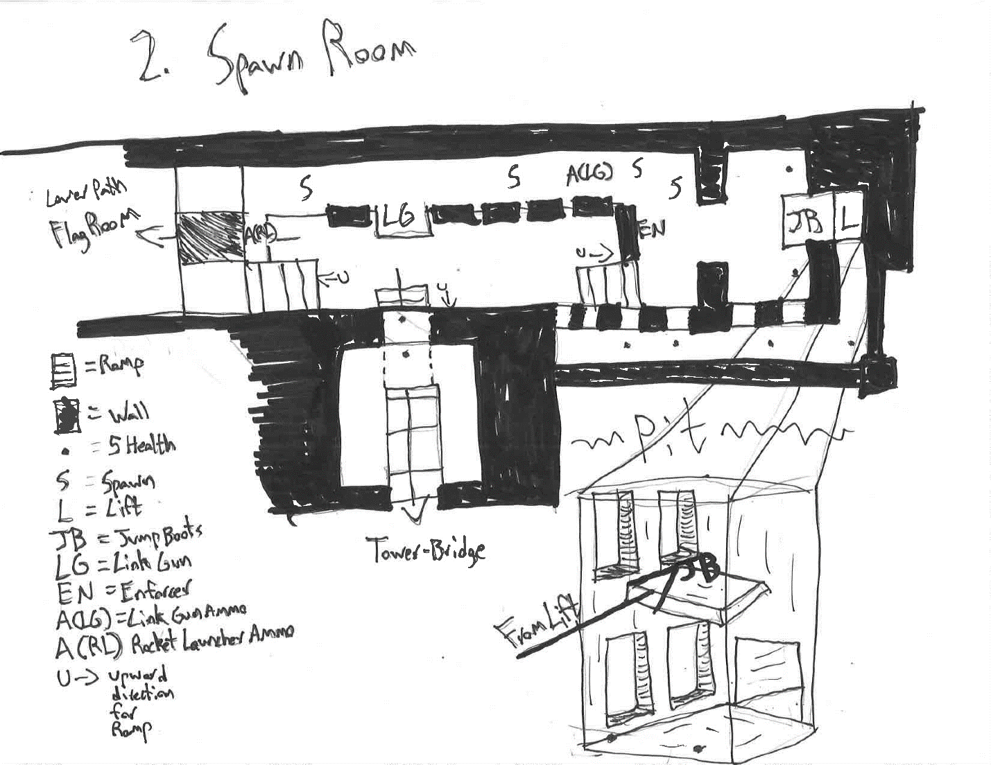

### Area Description

The Spawn Room acts as an outer lane for the map, and as an elevated primary spawn hub for defending players. Defending players are given direct view of an additional Enforcer and a Link-Gun, with a covered path towards the Flag Room, and an exit ramp towards the Tower-Bridge. Towards the back of the Spawn Room, players can exit through some windows onto a balcony with a view of the opposing Mini-Gun defensive position. Players can jump or translocate from this balcony as a one way shortcut towards the opposing Flag Room. Around the corner of the balcony area, there is small path towards a hidden elevator, at the top of which, players can obtain Jump-Boots. Once obtained, players can use advanced movement to jump back and forth across the pit or control the Tower-Bridge area.

### Requirements

The Spawn Room requires a kill volume at the bottom of the pit to reinforce the hazard.

## Tower-Bridge

### Detailed Area Map

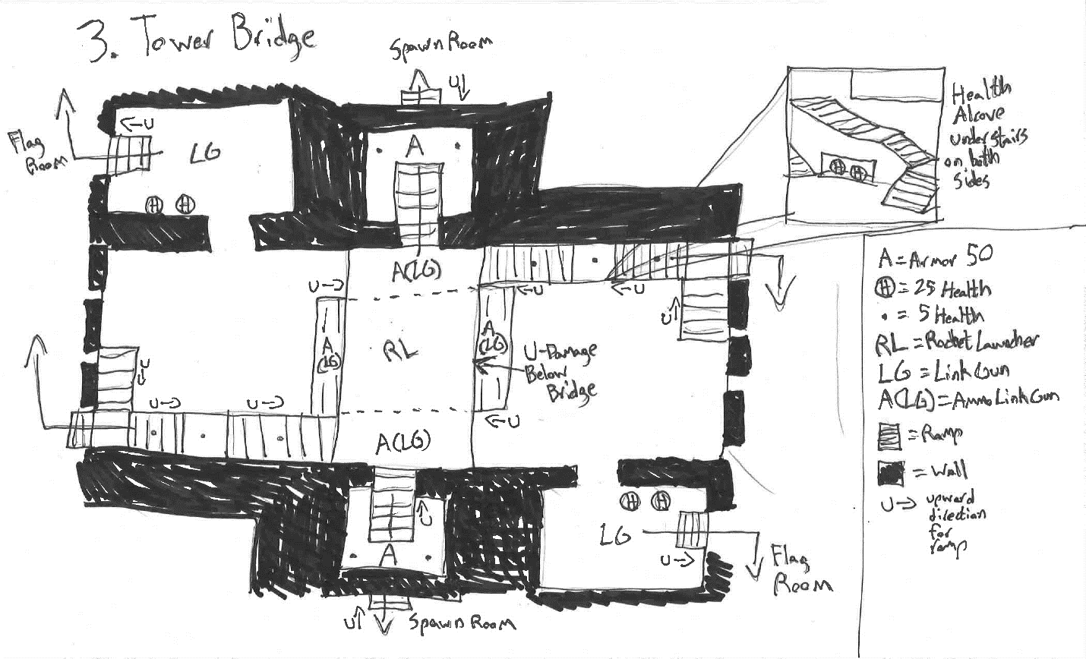

### Area Description

The Tower-Bridge area acts as the mid for the BridgeFort map. This Tower-Bridge has two elevations, the bottom lane connecting both Mini-Gun defensive positions, and the upper lane, a bridge connecting both towers. In the bottom lane, players can move up the central ramp onto the bridge, or into a side passage towards the opposing Flag Room, by moving underneath the bridge. The upper bridge lane connects two towers with ramps down to the Spawn room, above which sits an Armor pack to aid attacking players as they storm the otherwise protected area.   
  
The center of the Tower-Bridge area acts as an area of control, with a rocket launcher in the center of the bridge lane, and a U-Damage below the bridge. The separation of these two pickups makes controlling both somewhat difficult, but very attractive, as access to both pickups creates a powerful advantage.

### Requirements

No special assets or scripts are required for this area.

# Aesthetics

## General Thematic Elements

BridgeFort takes place between two cliff-side castle-forts, connected by a squat central bridge. The central structures are intended to be monolithic, constructed of a grey stone, with a deep rocky canyon below. The lighting depicts an afternoon sun, casting deep shadows in the Tower-Bridge area, with torchlight illuminating the interior castle. The interior of each castle is intended to be somewhat spartan, with war banners hanging from the many interior pillars.

## Flag Room

### Special Thematic Elements

The Flag Room is at the center of each fort, lit by torchlight with several war banners hanging from the walls. A carpet runs along the paths into and out of the Flag Room, colored to match the team who owns the fort. The centerpiece of the room is a throne, with lit braziers on either side.

### Lighting

A light falls on the flag and throne from an elevated tower window high above the ceiling. All else is lit by torchlight, and faintly by the afternoon sun coming in from the Tower-Bridge area.

### Visual References

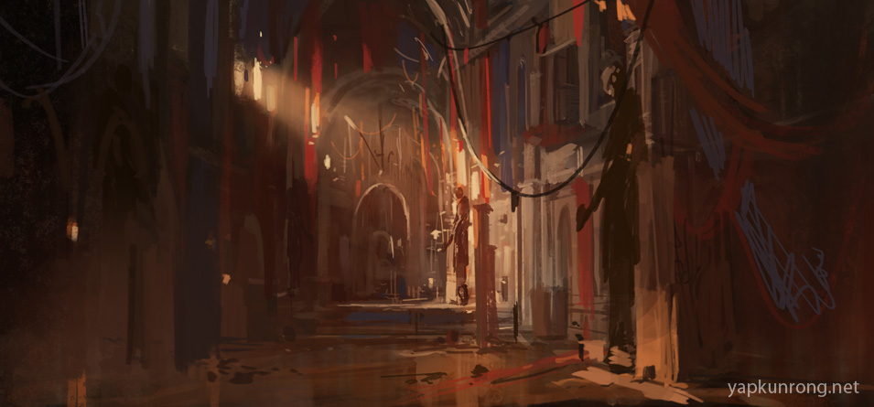

[2]

Layout

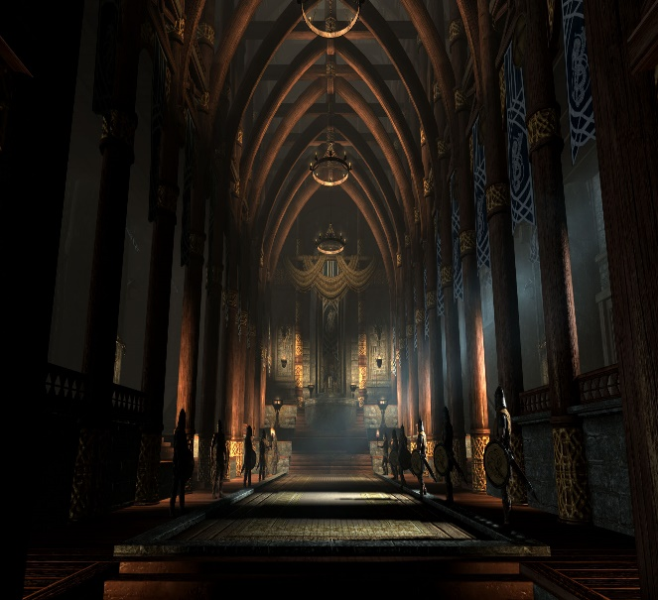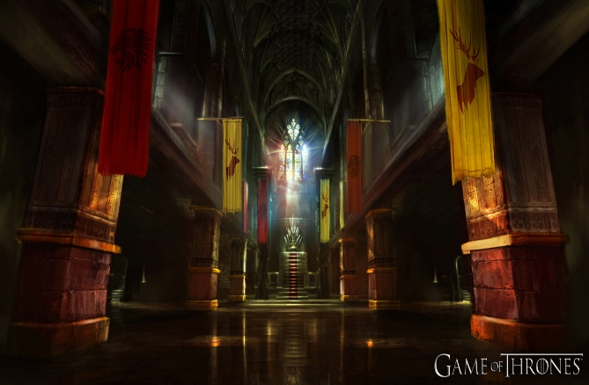

[3] [4]

Lighting

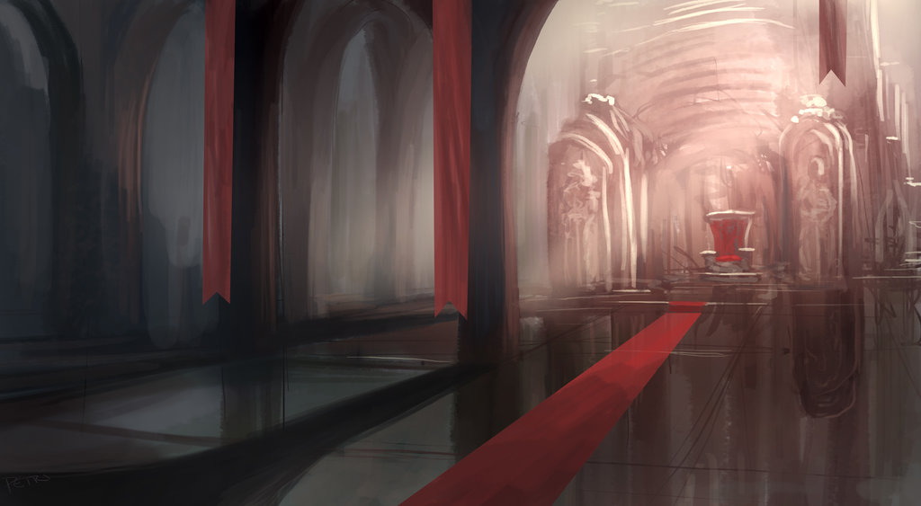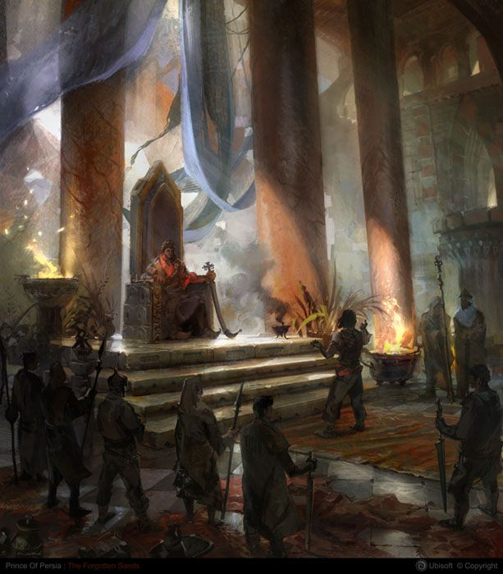

[5] [6]

## Spawn Room

### Special Thematic Elements

The Spawn Room appears like a long castle hallway, with deep-set, stone cut windows bringing in the afternoon sun. Here, war banners also hang from walls and pillars, and weapons adorn the walls. Additionally, carpets run along the floor leading players around to key areas. The back room containing the Jump-Boots appears as a storage area, with several crates stacked on top of each other.

### Lighting

This area is lit by the sunlight coming from the windows, and by torchlight hanging from the walls.

### Visual References

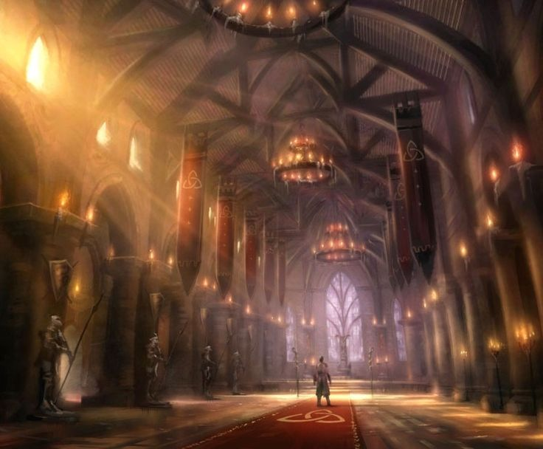

[7]

Layout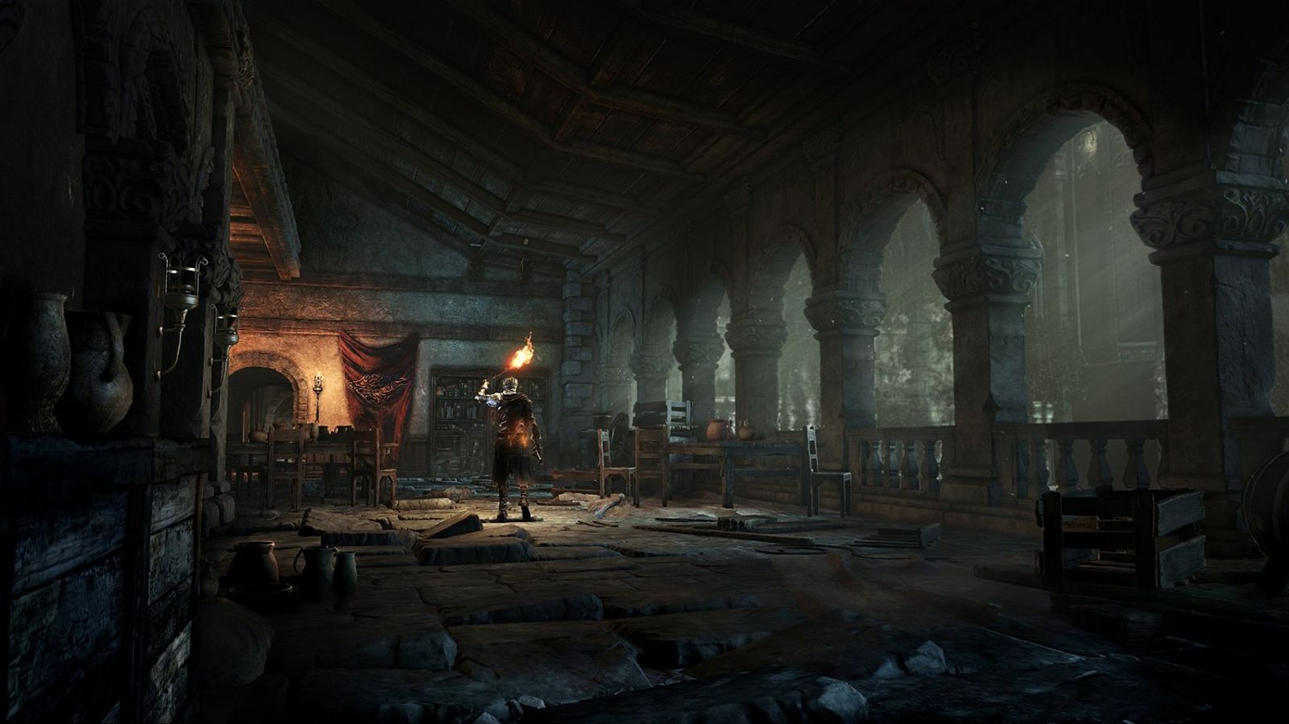

[8]

Lighting

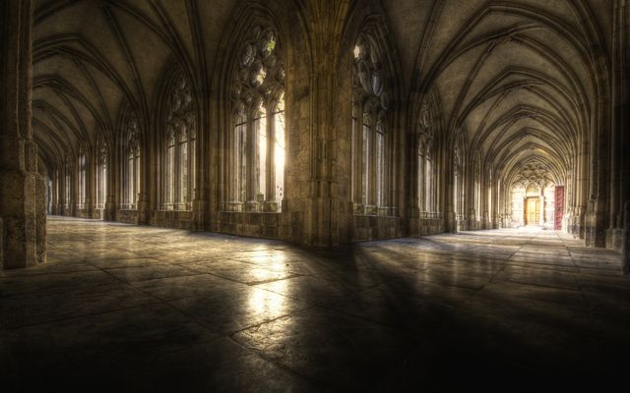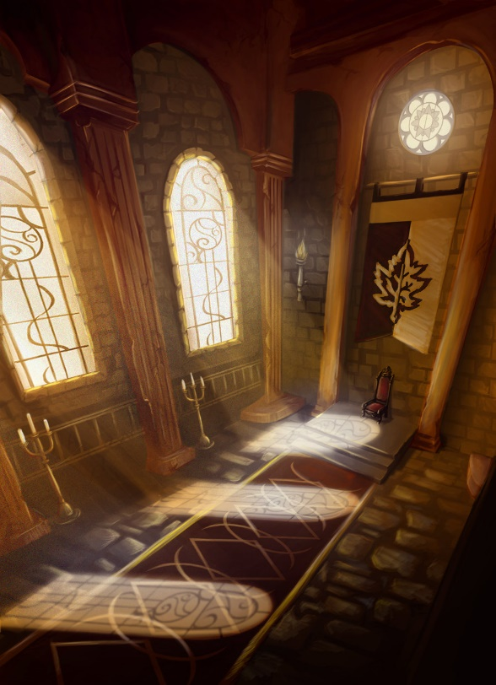

[9] [10]

## Tower-Bridge

### Special Thematic Elements

The Tower-Bridge area is the central focus of the map, and is dominated by monolithic stone towers, in addition to a squat, short bridge. Below the bridge, grates allow players to see into the deep rocky gorge separating the two forts, with fog covering the bottom. This area also has huge banners on each tower, themed to the colors of the team who owns them.

### Lighting

As this area is mostly outdoors, it is lit primarily by the afternoon sun. Burning braziers sit in front of each tower entrance, with torches emanating from within.

### Visual References

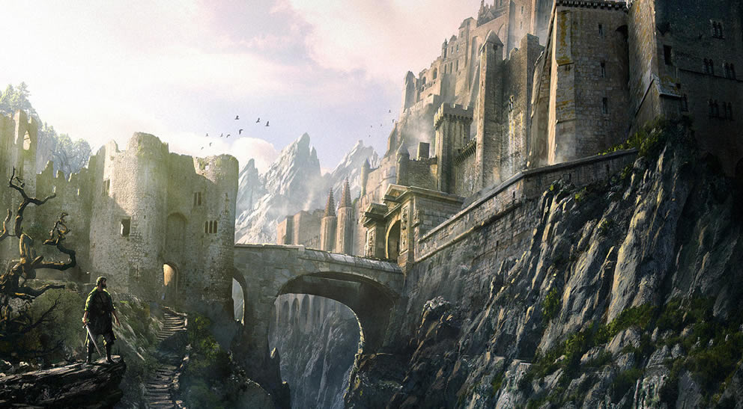

[11]

Lighting

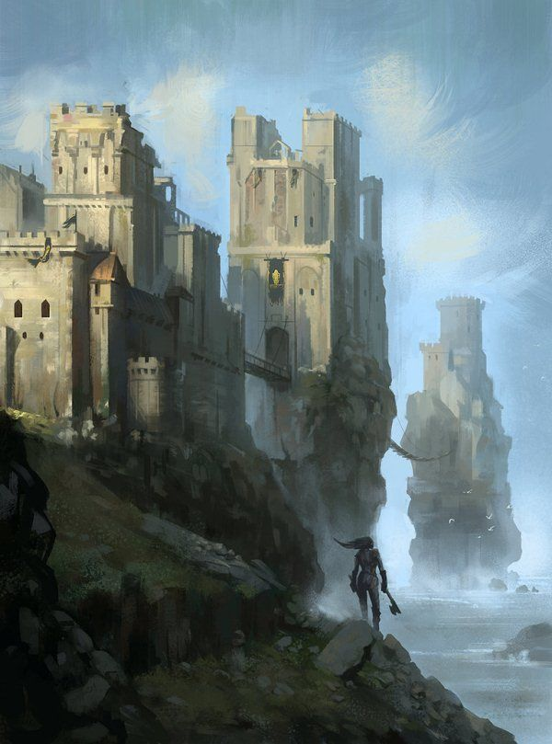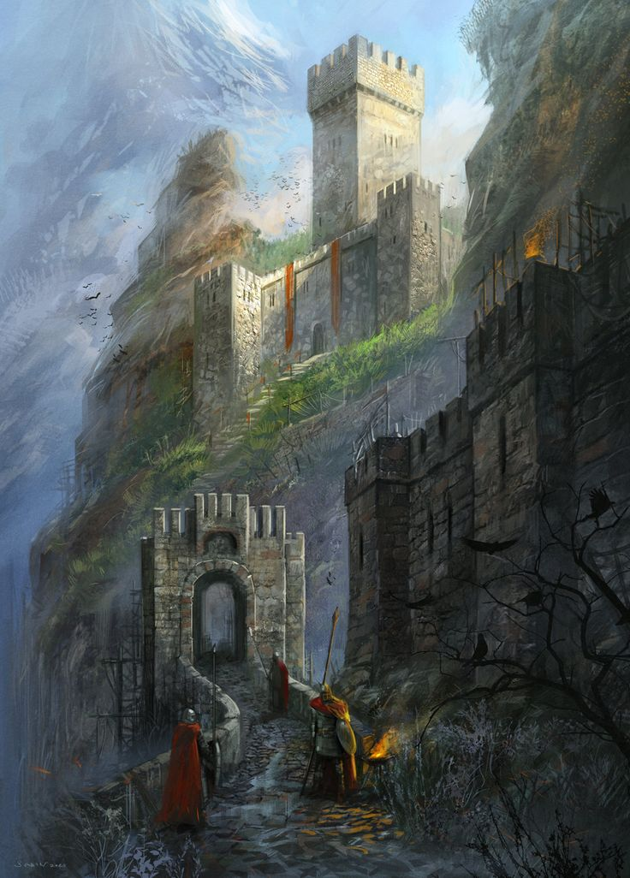

[12] [13]

Bottomless Pit Layout

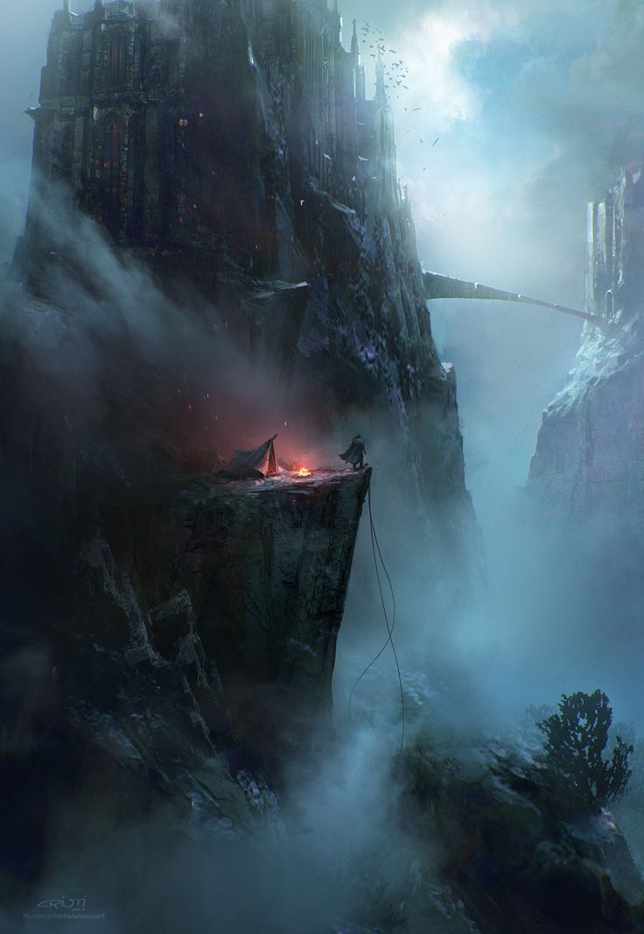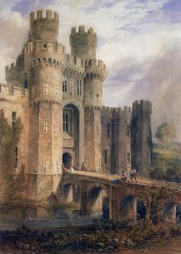

[14] [15]

# References

[1] “https://i.pinimg.com/736x/76/73/2d/76732dd32094dbcfd803361c79519ad8--dark-castle-gothic-castle.jpg”

[2] “http://1.bp.blogspot.com/-YfH1PAiJ0P8/UY9dOZt6XJI/AAAAAAAAAhM/ZxEEWHM-BHU/s1600/interior1LR.jpg”

[3] “https://youradagiox.files.wordpress.com/2013/09/issgardthrone5.jpg”

[4] “http://www.gamehdwall.com/wp-content/uploads/2013/04/Game-of-Thrones-Game-Throne-Room-Wallpaper.jpg”

[5] “https://img00.deviantart.net/f8e6/i/2013/203/4/b/throne_room_by_hetnoodlot-d6el68x.jpg”

[6] “https://i.pinimg.com/736x/74/4d/3c/744d3c83db68f6d39fd08d154eebd748--kings-throne-prince-of-persia.jpg”

[7] “https://i.pinimg.com/736x/b1/d0/55/b1d055c0910a48f0785fb0c10b666763--fable-ii-castle-interiors.jpg”

[8] “https://i.kinja-img.com/gawker-media/image/upload/s--gqHphdb0--/c_fill,fl_progressive,g_center,h_900,q_80,w_1600/tbmex1tf2kl3ahdcj3cr.jpg”

[9] “https://i.pinimg.com/originals/67/b5/39/67b5391dd48af2c432a9964d587f2272.jpg”

[10] “https://i.pinimg.com/originals/60/71/b7/6071b769b8125dd23d1d9df400778d28.jpg”

[11] “http://coolvibe.com/wp-content/uploads/2010/05/mountainfortress.jpg”

[12] “http://s3.amazonaws.com/pondly-media/wp-content/uploads/2012/12/28190332/zippo514_pyke_by_zippo514-d5j6q9c.jpg”

[13] “https://i.pinimg.com/736x/29/5c/ac/295cacdcfb6f3fc7d507222b05713040--fantasy-paintings-fantasy-art.jpg”

[14] “https://i.pinimg.com/736x/7c/7d/61/7c7d61055b7ff6795e844acbdc37cb56--fantasy-inspiration-work-inspiration.jpg”

[15] “https://i.pinimg.com/236x/f4/02/6c/f4026c5ec5acc3cc57ad6c297adc3f29--king-arthur-medieval-fantasy.jpg”